**Configuring an email server in Packet Tracer**

An *email server*, such as Gmail stores and sends email messages to email clients on request. We often send and receive emails on our mobile devices or computers. Have you ever imagined how this happens?  Well, whenever you compose and send an email to another person, the message you send first goes to a mail server.  It’s the mail server which then sends the email when it is requested from the email client (e.g Gmail App) of the recipient’s device.

So now, let’s configure a mail server in Packet Tracer. And have in mind that although our main focus is configuring an email server, we’ll still need services of a *DNS server* at one point.

1. Build the network topology:

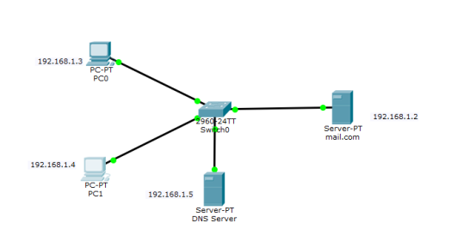

1. Configure IP addresses on the **PCs**, **DNS Server** and the M**ail Server**.

**Mail Server IP address**: 192.168.1.2/24

**PC0**    **IP address**: 192.168.1.3/24

**PC1    IP address:**192.168.1.4/24

**DNS** **server** **IP address**: 192.168.1.5/24

**3.**Now configure **mail clients** on the **PCs** and **mail service** on the **generic server**.

**Mail Clients:**

Click on **PC0**. Go to its **Desktop**tab, and click on **Email.** Configure the email client by filling in the user, server and login information. Be sure to **Save.**

**PC0:**

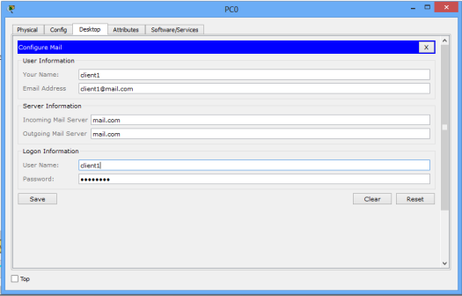

Configure mail client on PC1 in a similar way we did for PC1.

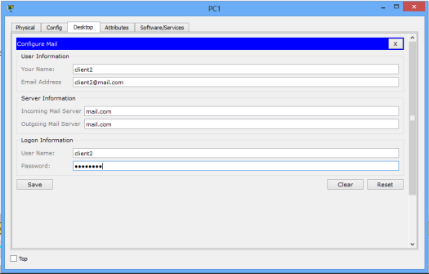

**PC1:**

Next, we’ll configure the **email server.**

To do this, click on the server, then click **Services**tab, pick **email**server from the menu.

Provide the **Domain name**of the server then click on**Set**to set it. In this example I’ve used the name ‘mail.com’.

Proceed and add **users** and provide their **passwords**. I have two email clients (users) with usernames ‘client1‘and ‘client2‘ with a common password**‘**adminkim‘

After entering a username and password, click on**Add (+)**to add the user to the server. You can optionally remove a user by clicking on **Remove (-).**You can change a user’s password by clicking on **change password.**

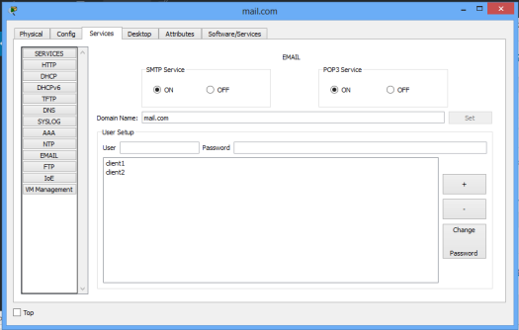

Try to relate this process to  what happens when you register an email account with a mail service provider(mail server) like Gmail. The processes appear to agree, isn’t it?

Now, notice that we set a **domain name** for the email server. For that reason, we should have a **DNS server** that will resolve this domain name (plus other domain names if there were) to an IP address.

So let’s configure a DNS server.

Click DNS server, click **Services**tab,then pick **DNS**. Turn the service**ON.** Set name-address pairs and add them to the server. You can view the DNS entry below:

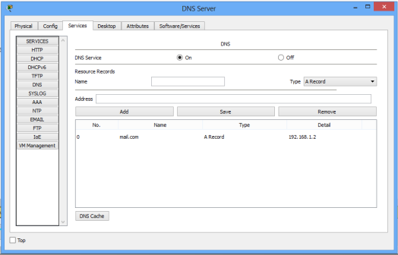

4. Lastly test the email service. Go to **PC0** **email**client, **compose**an email and **send** its to **PC1** email address (client2@mail.com).

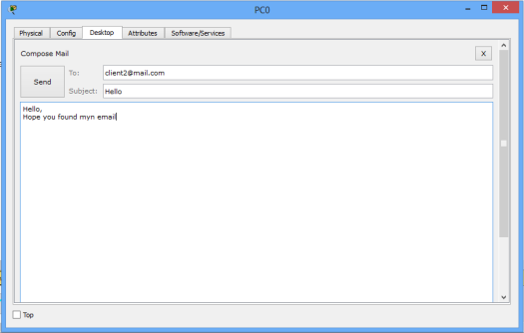

Try to see whether the email from **PC0** is received on **PC1**. On the **email** client of PC1, click on **Receive.**

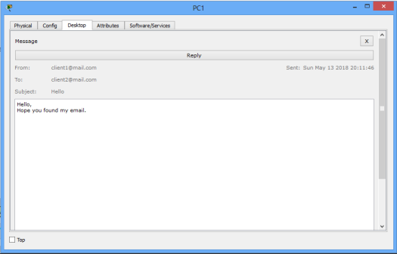

If everything is well set up, the email from **PC0** will be well received on **PC1**.